**Set 4 – Campean Adrian, Pipirigeanu Valentina, Deaconu Mircea**

Built in the DPSK modulator shown in the figure below , Tb=1s, simulation time 10 s.

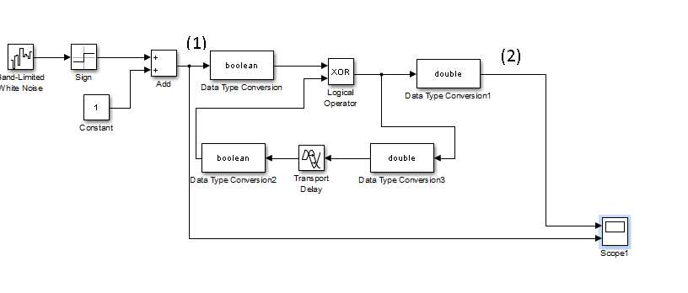

Transport delay is o bit period delay.

Compare the data signal (1) with the differentially encoded one (2). Make a print screen of the signal in scope 1 What can you observe?

*The scope output shows two signals from a DPSK modulator: the original data signal and the differentially encoded signal. The original data is a binary sequence, while the differentially encoded signal changes only when the original data changes from one bit to the next. This differential encoding helps make the communication system more robust against phase shifts in the transmission channel.*

Considering that the modulation / demodulation process in performed in ideal way (no delays, jitter, etc ) implement the baseband DPSK demodulator like in figure below

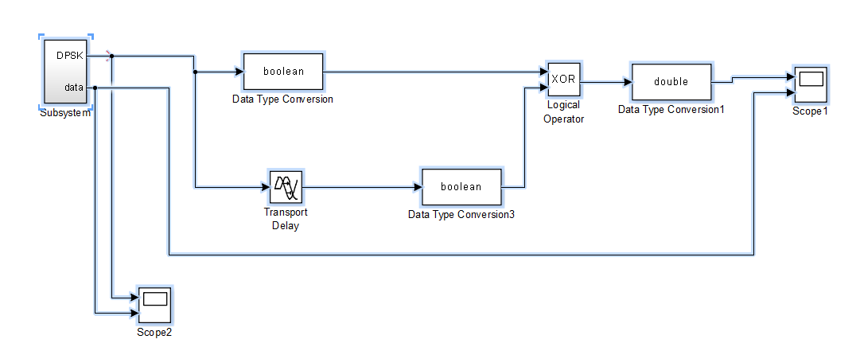Make a print screen of the signal scope 2. Compare the original data -take from the subsystem point (1) with the recovered one. Comment the results.

*The provided scope outputs display the performance of a DPSK demodulator. The upper trace in each scope likely represents the original binary data signal, while the lower trace seems to be the recovered data after demodulation. The recovery process in DPSK involves detecting changes from one bit to the next rather than the absolute bit values. As such, the lower trace changes state only when the original data signal does, consistent with DPSK demodulation principles. The observed one-bit period delay in the recovered signal is expected and indicates the demodulator is effectively reconstructing the original signal.*

**Set 5**

5.1 What is the role of each block in the carrier recovery scheme from BPSK

* Subsystem – BPSK modulator;
* Analog Filter Design – Butterworth filter, bandpass filter, as flat as possible in the frequency domain;
* Gain – multiplies the input by 100;
* Saturation – limits the signal to an upper and lower bound;
* Product – multiplication of inputs;
* Data Type Conversion – converts input to another data type;
* JK Flip Flop – stores binary information.

5.2. Change Tb=4, f0= 10Hz. Show (make print-screen) of

* the modulated signal and the data (in time domain)

*The modulated signal's phase shifts align with the changes in the binary data signal, which is the fundamental principle of BPSK modulation—each bit change in the data signal results in a phase change in the carrier signal. This phase change is what encodes the data onto the carrier wave for transmission. The fast oscillations in the modulated signal represent the carrier, and the phase flips are evident at the transitions of the data bits, indicating successful modulation.*

* the spectrum of the modulated signal,

*The spectrum analyzer output depicts the frequency domain representation of a BPSK modulated signal. The central peak corresponds to the carrier frequency, and the symmetrical sidebands around it are typical of a modulated signal, reflecting the frequency content of the modulating binary data signal.*

*The spectral spread around the carrier frequency is a result of the data signal's characteristics, influenced by factors like the bit rate, the shape of the data pulses, and any filtering that might have been applied. In this case, the sidebands and the central peak indicate successful BPSK modulation, where the data is encoded in the phase of the carrier frequency, resulting in the observed spectral pattern.*

* the recovered carrier (time domain), compared with the one from the transmitterA screenshot of a graph

  Description automatically generated

*In BPSK, the data is contained in the phase changes, so the timing of these changes is crucial. The key is that the phase changes occur at the correct time.*

* the spectrum of the signal at the receiver after the multiplier

* the recovered data in time domain, compared with the one from the transmitter

5.3. If the 2nd BPF in the carrier recovery block has the cut off frequencies 2*pi*10*0.7 / 2*pi*10*1.3, sketch its attenuation characteristic. Fill in the table

|  |  |  |  |  |  |  |  |  |  |
| --- | --- | --- | --- | --- | --- | --- | --- | --- | --- |
| f (Hz) | 4 | 5 | 6 | 7 | 10 | 13 | 14 | 15 | 16 |
| attenuation(dBm) | 14.9864 | 15.7654 | 14.6658 | 13.0548 | 21.9903 | 7.8654 | 11.3461 | 13.8493 | 14.7929 |

